On behalf of the International University Sports Federation,
the Sports Student Union of the Ukraine and
the Ukrainian waterski and wakeboard Federation
we have the honor and the pleasure of inviting
the National University Sports Federation of your country
to participate in the
2020 FISU World University Waterski and Wakeboard Championship to be held in Dnipro, Ukraine, from 24th to 27th of September.

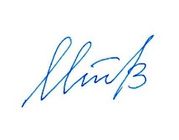
Olexiy Martynov Oleg Matytsin Evgen Imas
President of the President of FISU SSUU President
Organising Committee

